**INDUSTRIAL MECHANISATIONS BASED ON OBSTACLE AVOIDANCE**

Ssenyonga Kizito

St. Lawrence University, Uganda [Email. [ssenkiiz4@gmail.com](mailto:ssenkiiz4@gmail.com) ]

**Abstract**

This article presents different mechanical applications which employ obstacle avoidance technics for automation of many industrial activities. To understand the working mechanism of this technology I used a prototype robot developed using ultrasonic sensors and controlled by an Arduino microcontroller. Ultrasonic sensors are fixed in front of the robot to detect obstacles in front of the robot. Once an obstacle is detected, the robot deviates from its path to choose an obstacle free path through the microcontroller. This mechanism can be integrated in a number of applications to develop intelligent mechanical systems for automation purposes such applications can be used in package delivery robots, intelligent vehicles that can avoid collisions on the roads and many more other applications.

**Key words: Ultrasonic Sensors, Intelligent Mechanicals , prototype, Free path**

**Introduction**

In today’s world robotics is a fast growing and interesting field. Advanced development of Artificial Intelligence (AI) has given rise to robots that can perform desired tasks in unstructured environments and are intelligent enough to cover the maximum area of provided space without continuous human guidance. Obstacle detection is primary the requirement for this kind of autonomous robot to execute the tasks mentioned above. The robot should have capacity to collect information from surrounding area through mounted sensors on the robot, analyze the information and make a decision of the new direction which should be obstacle free using the microcontroller.

Robotics is generally a combination of computational intelligence which involves memories programmed instructions and physical motors that perform movement and rotational functions. This prototype proposes a robotic vehicle that has a microcontroller which processes information received from the sensors and sends commands to steer the wheels in a direction different from the direction of the obstacle.

Designing the robot prototype, we assumed a flat terrain therefore wheels were used for movement of the robot, however real life terrain is rough. All the design for a functional robot should take in account propulsion energy changes to push the robot over rough terrain, move up inclined planes and overcome terrain slopes. More so the reflective surface of the obstacle is assumed flat, however different obstacles take on different shapes from definite shapes i.e. squares, circles and prisms to irregular shapes such a stones.

Many researchers propose different methods for developing robotics such as collision avoidance robotics based on ultrasonic sensors, video image and bit map image detection technologies. In this paper we focus on designing a obstacle avoidance robot based on Hc-SR04 ultrasonic sensor.

**Research methods**

**Ultrasonic sensor HC-SR04**: It is a non-contact based distance measurement system and can measure distance of 2cm to 4m. [1] It sends out a high-frequency sound pulse and receives the echo of the sound pulse after bouncing off an obstacle. The sensor has two openings on its front.

* Tiny speaker to transmit opening ultrasonic waves

## Microphone to receive the ultrasonic waves

The ultrasonic sensor uses the time difference between sending of the sound pulse and receiving the echo to determine the distance between the robot and the obstacle in front of the sensors. This distance between the obstacle and the robot can be calculated using the formula below:

$$Distance, d=\frac{Time,t x Speed of sound in air,s }{2}$$

Note: The speed of sound in Air (343m/s) [2]

Ultrasonic sensors work at a frequency of 40 KHz and have a deviation angle maximum of about 30° [3], so usually robots need more than one sensor to be able to measure the distance of an obstacle in its vicinity.

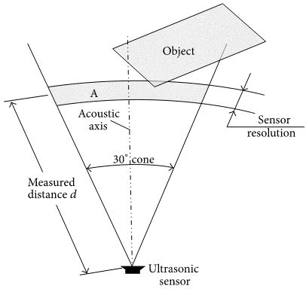

Two dimensional projection of the coverage area of an ultrasonic sensor [3]

Considering the coverage area of ultrasonic sensors, we therefore need at least 3 ultrasonic sensors for proper coverage. An ultrasonic sensor however has some limitations and some obstacles may not be detected because:

* Since at least 3 sensors are required to better area coverage, these sensors create interference amongst themselves.
* The shapes or positions of the obstacles may be such that they deflect sound waves away from the sensors.
* The size of the obstacles may be too small to reflect enough of the sound wave back to the sensor to be detected.
* Some obstacle objects can absorb the sound wave all together (cloth, carpeting, etc.), which means that there is no way to detect them accurately.

Arduino Uno***:*** Arduino Uno is an ATmega 328p Microcontroller based prototyping board. It is an open source electronic prototyping platform that can be used with various sensors and actuators. It is relatively cheap, plugs straight into a computer’s USB port, and is simple to setup and use when compared to other development boards.

#### Arduino is the main processing unit of the robot. Out of the 14 available digital I/O pins, 7 pins are used in this project design [4].

Some of the features of Arduino Uno include:

* **Open source design:** large community at Arduino.cc/forum/ of people using and troubleshooting it.
* **Easy USB interface:** the chip on the board plugs straight into your USB port and registers on your computer as a virtual serial port. This allows us to serially communicate which is an extremely easy protocol.
* Convenient power management and built-in voltage regulation. 12v can easily be regulated to both 5v and 3.3v
* Easy to find and cheap microcontroller
* Countless number of hardware features like timers, PWM pins, external and internal interrupts, and multiple sleep modes.

Some other specifications are

* A 16 MHz clock
* 32 kb flash memory
* 13 digital pins and 6 analogue pins
* ICSP connector to re-bootload your chip and for bypassing the USB port and interfacing the Arduino directly as a serial device LED attached to digital pin 13 for and easy debugging of code

#### L293D: It is a motor driver which can provide bi-directional drive current for two motors [5].

#### Servo Motor: The Tower Pro SG90 is a simple Servo Motor which can rotate 90 degrees in each direction (approximately 180 degrees in total) [6].

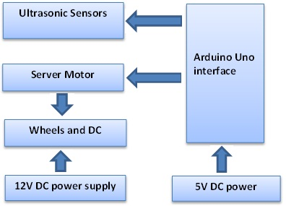**Architecture of the robot**

Architecture of the robot shows the output and input relationship between the hardware elements

**Flow chart**

**YES**

**NO**

**Has robot reached the destination?**

**Is there any obstacle?**

**YES**

**YES**

**NO**

**NO**

**. Robot turn left**

**. Robot moves forward**

**. Robot turn right**

**. Robot move forward**

**. Robot stops**

**. Robot turn left and measure the distance to the next obstacle**

**. Robot turn right and measure distance to the next obstacle**

**Robot in motion**

**Is distance left > distance right**

The algorithm of operation of the robot

Architecture of the robot

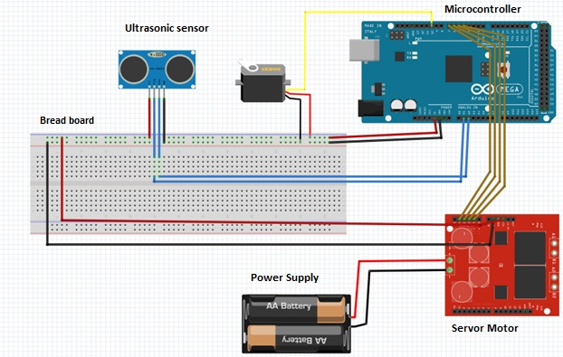

Schematic diagram of the robot components

**The working mechanism of the robot**

* The working mechanism is represented in the flow chart diagram in figure above.
* The robot is switched on by powering it with 5V DC from an external battery. The motors start rotating and thus the robot will start moving forward.
* During this time the ultrasonic sensor continuously keeps calculating the distance between the robot and any reflective surface in front of the ultrasonic sensors.
* Arduino microcontroller uses a specific value set as the threshold for the minimum acceptable distance between the obstacle and the robot. This value is programmed into the micro controller as the basis for comparison and decision making during the robot motion. For our specific prototype we set 60cm.
* Considering the speed of the robot, if an obstacle is more than 60cm from the robot, the robot keeps moving, thus less danger of collision.
* In case of an obstacle the robot stops and rotates to the left side and a new calculation of distance to the nearest obstacle is calculated, the after the robot rotates to the right and a corresponding distance to the nearest obstacle is calculated. The two distances are compared and the robot takes the distance with the highest value.

## **Writing the code**

To write an Arduino sketch or a code, some basic knowledge about C and embedded C should be known. To write this code, Arduino Integrated Development Environment or Arduino Software (IDE) is used which is also open source like the Arduino Uno board (Arduino, 2015) [8]. See the appendices for programming code that enables the robot to detect an obstacle which is in front of the robot and deviate from its path to a new path that is obstacle free.

**Results**

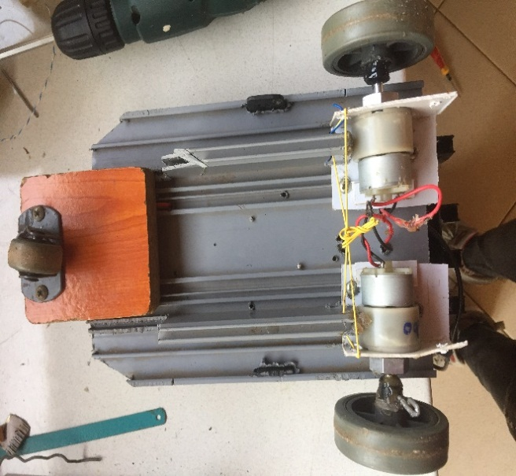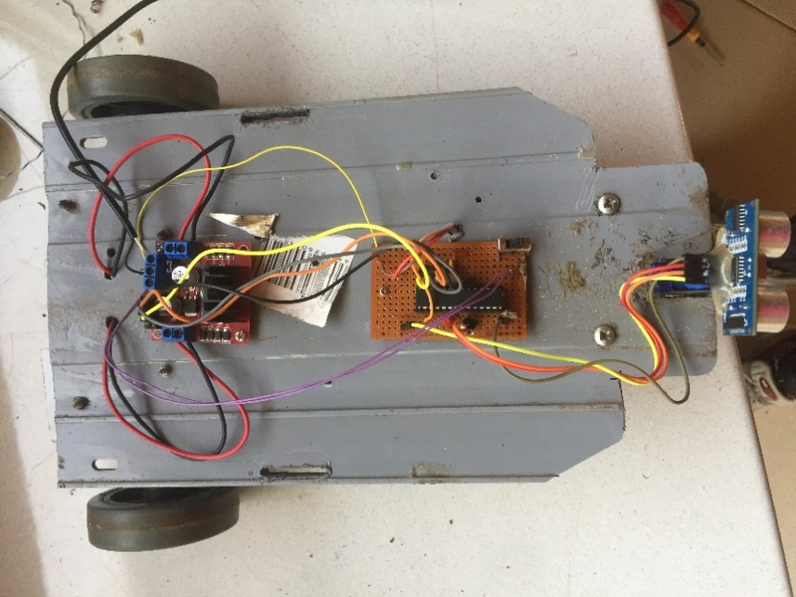

DC motors

Complete robot

**Applications Obstacle Avoidance technology**

Using the obstacle avoidance technology we propose a number of applications

1. **Automation of automobiles and transport**: In our project the prototype we used worked well in an ideal environment. However if the more research is done, we can develop sophisticated robots that can also detect and avoid moving obstacles. This can be achieved through the use of neural networks. This can be the basis of developing self-driven automatic vehicles for both human and cargo transportation.
2. **Reduction of road accidents:** using this technology we can be used to reduce road accidents. Many cars have integrated obstacle detection technology to detect any obstacles in front of the vehicles. Once an obstacle is detected before the car, the car deactivates movements until the obstacle is cleared. So if there is another vehicle or human crossing in front of the vehicle stops automatically.

Alternatively, the technic can be used to detect driving lanes and road barriers to keep vehicles on track. This also contributes to reduction of accidents on the road. Many drivers cause accidents because of irresponsible driving out of their lanes. This may be due to high fatigue levels, influence of drugs and alcohol etc.

1. **Vacuum cleaning:** Automatichousehold cleaners can be manufactured using obstacle avoidance technics. However careful calculation of distances to the obstacles required to clean corners and very close to walls as these may be omitted as automatic vehicles may want to avoid collisions.
2. **Military applications:** The need for automated and effective ammunition for military applications has tremendously risen. This is in the bid to save lives of human soldiers. The technology of obstacle avoidance has thus been employed to build these robots. These robots can thus be employed in dangerous and harmful areas example to put out fires, rescue patients etc.

**Conclusion and recommendations**

Collision detection and avoidance technologies have paved way for production of autonomous robots. This innovation however is challenged by the transient response time between detection of an obstacle and movement in the obstacle free direction. This in term limits the speed of operation of the robots. More research is needed in this area so as improve on the operation speed of the robot.

.

**References**

[1] Product User’s Manual – HCSR04 Ultrasonic Sensor *Prepared by Cytron Technologies Sdn. Bhd.*19, Jalan Kebudayaan 1A, Taman University, 81300 Skudai, Johor, Malaysia.

*Tel: +607521* *3178* *Fax: +607521* *1861*

[2] Zitzawitz, Neff & Mark Davids. Physics: Principles and Problems, New York: Glencoe, 1995:203

[3]O. Khatib, “Real-time obstacle avoidance for manipulator and mobile robots,” *International Journal of Robotics Research*, vol. 5, no. 1, pp. 90–98, 1986.

[4] <https://www.arduino.cc/en/Guide/HomePage>

[5] L293x Quadruple Half-H Drivers. Texas Instruments, Post Office Box 655303, Dallas, Texas 75265

[6] <https://www.arduino.cc/en/reference/servo>

# [7]. Widodo Budiharto.  “Intelligent Surveillance Robot with Obstacle Avoidance Capabilities Using Neural Network” Volume 2015 |Article ID 745823

View at: <https://www.hindawi.com/journals/cin/2015/745823/>

[8]. Global Journal of Researches in Engineering: H Robotics & Nano-Tech Volume 17 Issue 1 Version 1.0 Year 2017 Type: Double Blind Peer Reviewed International Research Journal Publisher: Global Journals Inc. (USA)

Online ISSN: 2249-4596 Print ISSN: 0975-5861