**Mobile app record management system for ANC department:**

OKELLO JACOB BOBBY¹ and Lubega John Bosco¹

1-St. Lawrence University, Uganda, Kampala [email. agendalubega@gmail.com]

**Abstract**

The research addresses the use of practitioner-prescribed software applications for health management purposes when used on a mobile device (e.g. mobile phone, laptop, smart watch, or tablet) with the intent to evaluate, diagnose or treat an illness, injury, disease or its symptoms. However it does not address mobile-based software applications (MSAs) that are used in the function or control of another FDA-cleared or approved stand-alone hardware medical device. Neither does not address MSAs accessible to the general public for download (including direct-to-consumer [DTC] or “over the counter” applications), applications that promote general wellness, or applications operated by a healthcare practitioner in a clinical setting for remote health monitoring.

The author research has some benefit plans which may exclude coverage of consumer wearable or personal mobile devices (such as a smart phone, smart watch, or other personal tracking devices), including any software or applications. DTC applications are generally excluded from benefit plan coverage

Mobile-based health management applications are considered **medically necessary** when *all* of the following criteria in I and II have been met: Criteria to evaluate the mobile software application (MSA) and  Criteria to evaluate the appropriateness of the MSA for the individual.

**Key words: MSA , Smart watch , ANC**

# INTRODUCTION

The rationale of the Automated Mobile ANC App Records Management System is to develop a system that can track Antenatal records such that medical practitioners can do a follow up of the way pregnant mothers have been handled and thus could contribute to arriving at cures very fast and conduct of more research based on the existing available records easily. According to H. wills keeping antenatal records is very important to every Hospital because it helps doctors to know the exact health status of the pregnant mother.

## BACKGROUND OF THE STUDY

Pope John’s Hospital Aber is a public Hospital found in Oyam District, Northern Uganda. The Hospital was officially opened in 1963 as the first of its kind in the area and it saved people’s lives because by then there was no good Hospital. It is run by Lira Diocese with the help of board of directors. It started with two nurses and one doctors but right now it has expanded to 172 staff, nurses and doctors inclusive because it admits a number of patients per day both in patients and out patients.

Pope John’s Hospital Aber offers the following services; counseling and guidance, Internal medicine, Minor surgery, pediatrics, laboratory, Antenatal care, family planning, immunization, IDP, OPD, eMTCT services, Health education, orthopedic services, Dental services, provision of ARVs, and many others. It has a number of departments like the immunization department, treatment department, antenatal care department (ANC department) among others. The researcher will carry out his research in the antenatal care department because it receives a number of pregnant women who come every day for antenatal care, medical checkups, treatment, among other needs.

**Statement of problem**

Records management has become a problem that has affected the running of many organizations, business and government institutions and at so many instances the organization have failed to prove and defend themselves due to poor records build up and has become a constant time wasting in decision making.

**Purpose of the study report**

According to Benedon (1978) *Records management encyclopedia of library and information science*, records are very vital and essential tools for administration and they are means by which operational process and functions are performed., Costly records are of secondary importance would collapse and would be necessary to replace them would constitute disaster, Legal records are necessary for the organization to operate legally to protect itself or the individual, Emergency records, those that are not vital except in the case of an emergency.

Digital based records, information recorded in a digital form such as a computer floppy, Cd, etc.

**Objectives, research questions and hypothesis**

most people with far reaching impact was mobile phones. Hence the reason for the App (Mobile App for Antenatal Management System: MAARMS).

In Addition to that, there are many technologies or developing mobile app, such are; the web platform ionic, Microsoft’s Xamarin, Apple’s Xcode, etc. Buy here we chose Google’s Android Studio to target Android devices.

As per accessibility of contents in a database, Raglan states that questions about data must be answered quickly, changes made the data by different users must be applied consistently and access to the data must be restricted.

**Scope**

The system will exclusively be designed and developed for Pope John’s Hospital Aber records Management Department in general and the Antenatal care records department in particular. This department is solely responsible for keeping ANC, medical immunization and related records for both pregnant women and infants under the age of five and keeping tracks of this information.

The records management system will be designed in such a way that makes it possible to access it through any computer, this will enable the user interface and the storage of data.

By automating the system, the study attempts to track Pregnant Mothers and child, drugs and medications for the health Centre. This system shall provide a means of easy recording, storing and retrieval of timely information whenever required.

Upon completion of the proposed system, the following shall be achieved.

* The system will help future scholars and researchers who may be interested in the developing similar prototypes for academic reference.
* The system will enable easies storage and retrieval of information.
* The system will enable the medical officers to track Pregnant Mothers and child details &drugs
* The system will tract the HIV program defaulters, thus preventing HIV eMTCT
* The system will facilitate generation of consistent reports and the errors in data is done away with.
* Activities regarding daily routines of the Hospitals will be effectively monitored from a single location by the administrator hence more efficiently and reliability.

This reveals what other scholars have done before related to an Automated Records Management System, the strengths in their systems and the weaknesses, which are to be solved by the current system

**Significance**

Hospital/hospitals have played significant roles in treatment and eradication of different diseases and this explains the reason for their existence. And for that reason a need to make things quick and reliable.

**Literature review**

Components of the system

Most advanced mobile applications utilize three‐tiered architecture: the main interface layer which users interact with, the business logic layer which handles user queries and actions, and the data layer which is responsible for storing the data to be used in the form of a database. Java was used for the final system design, as it is a more powerful language to process forms and database actions, thus allowing more functionality. Security implementations would also be more robust in a Java, thus strengthening the reason for the change.

Security and administrators

security is very important within the system. Various ‘layers’ of security need to be created according to the user accessing the data. Thus an access list needs to be created. Currently systems have minimal security features and files are kept in a filing cabinet. A mobile application will improve security from within the system, as it will restrict access of these files to only the relevant people via a password protection scheme.

In addition to that, user passwords are not stored as plain text, but rather in a hashed/encrypted format. Thus, even if one manages to break inside the system, it will be hard to do anything more.

**RESEARCH METHODS**

The first step consists of research; basically, it’s about researching on people’s needs and how one can solve them. The latter being the design and development of a mobile app/system for managing antennal care data. Developing the app also requires research on technologies to use; the best to apply and how to apply them. Although there is multiple platform one can use to reach their objectives, research showed that the most with far reaching impact was mobile phones. Hence the reason for the App (Mobile App for Antenatal Management System: MAARMS).

In Addition to that, there are many technologies or developing mobile app, such are; the web platform ionic, Microsoft’s Xamarin, Apple’s Xcode, etc. Buy here we chose Google’s Android Studio to target Android devices.

### Prototype design

The first Iteration of our system began by designing and implementing a high-fidelity prototype. This was interface designs of the system; no functionality at all but simply how the system was to look and how pages were to link to each other.

Even though we had insight on data to collect and the look we wanted, we also had some informal interview sessions with two doctors outside of working conditions to gather their thoughts on how the system should be implemented. In the interview we explained the project proposal. Their input was that they thought the project was very interesting.

Next are the different screens of the prototype;

### Figure 1. Splash screen

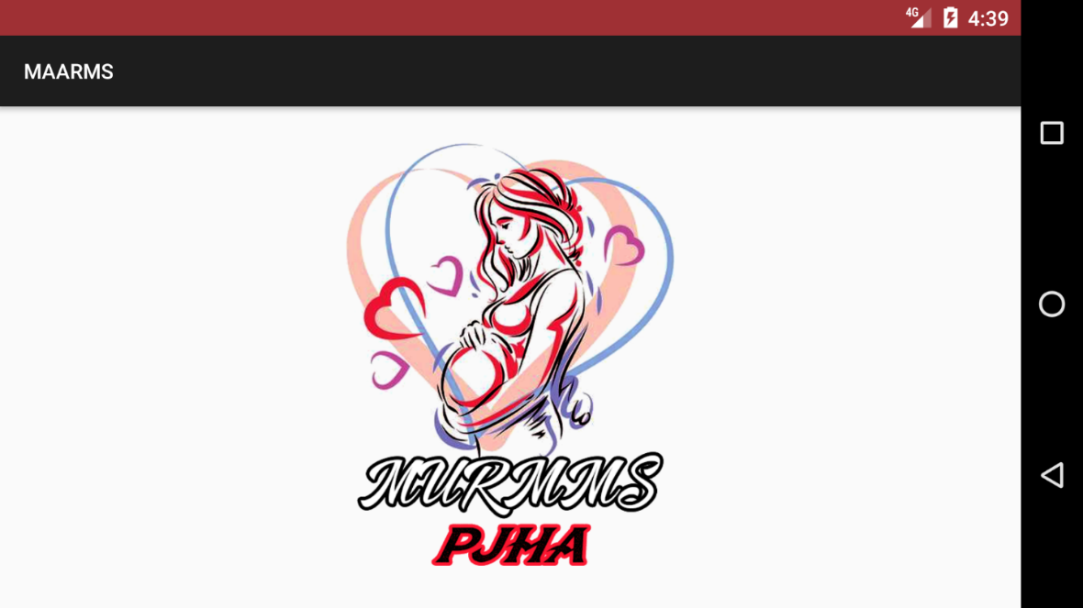

### Figure 2. LOGIN SCREEN

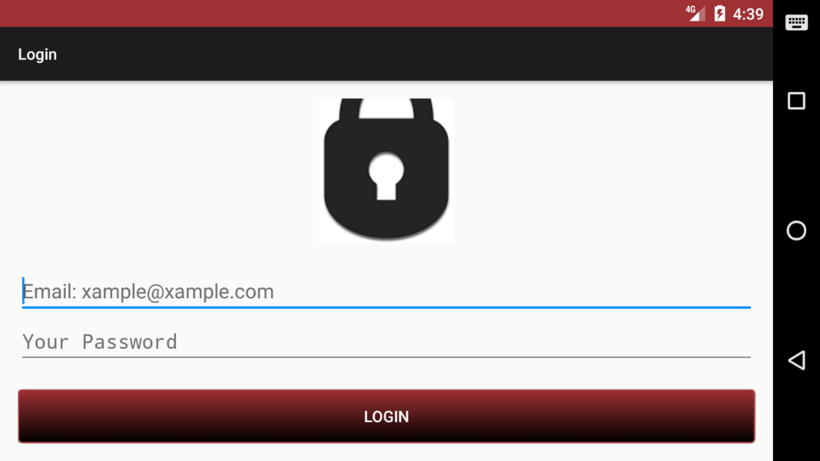

### Figure 3. PATIENTS SCREEN

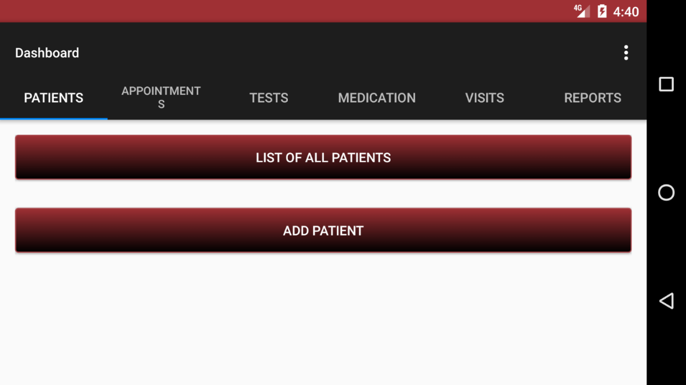

### Figure 4. APPOINTMENTS SCREEN

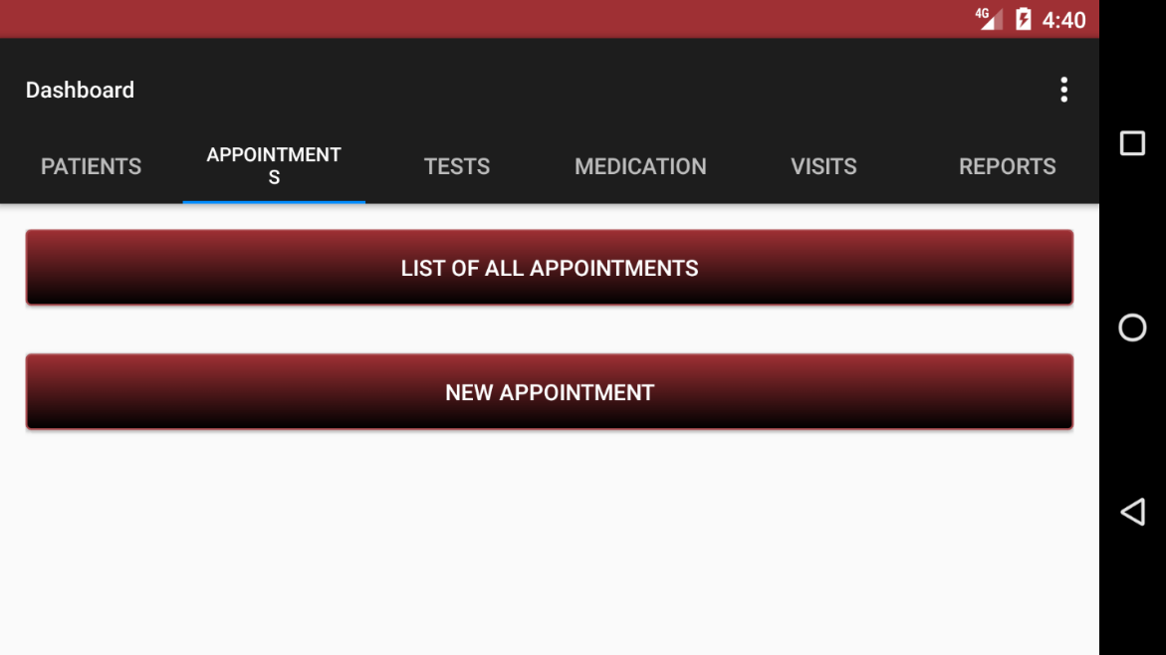

### **Figure 5. TESTS SCREEN**

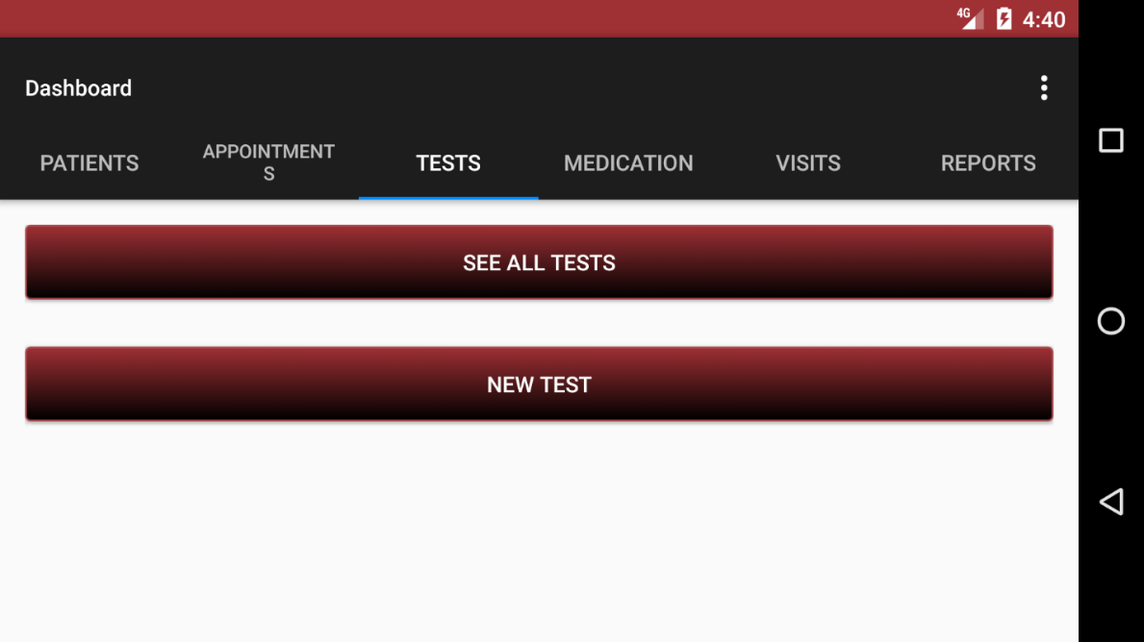

### Figure 6. MEDICATION SCREEN

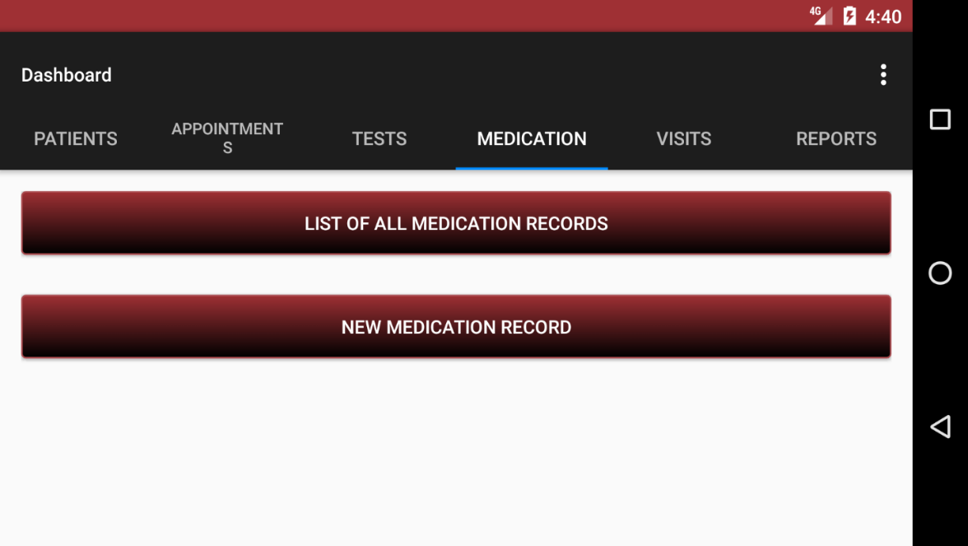

### **Figure 7. VISITS SCREEN**

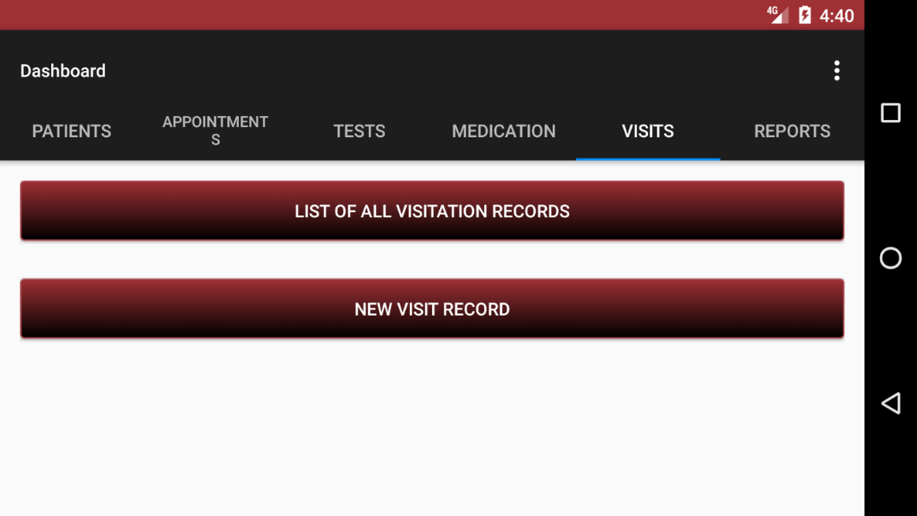

### Figure 8. REPORTS SCREEN

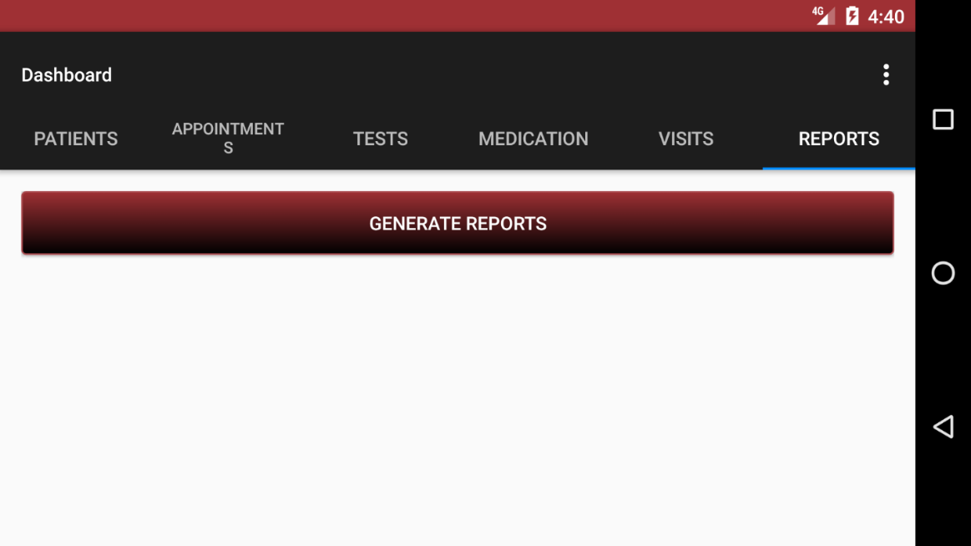

### Hardware requirements

**Table 1. shows summary of hardware requirements.**

|  |  |  |
| --- | --- | --- |
| Hardware | Minimum requirement | Reason |
| Android Powered Smartphone | Android 4.4 | Moderate |
| RAM | 512MB | Moderate |
| Disk space | 20MB | Enough |
| Bandwidth | 100Mbps | Enough |

### Software requirements

**Table 2. Shows summary of software requirements.**

|  |  |  |
| --- | --- | --- |
| Software | Minimum Requirement | Reason |
| Web server | SQLite Server | Extensible Web server |
| DBMS | SQLite Server | Easy to use and scalable |
| OS | Android OS 4.4+ | Proprietary Support |

## System functions

### Functions provided to all users of the system.

The system will help both the security department in the city as well as the public to get access to information about crimes that may be committed under in certain places.

### 

### Functions provided by the police department

1. Entering antenatal patient information into the system.
2. Viewing information about antenatal patients within the hospital database.
3. Managing antenatal patient information.
4. Generation of patient reports and previous records.

## System design

**Figure below shows a flow chart that demonstrates how the system works.**



Figure 9: System Flow Chart

### 

**Use case Diagram**





Figure 10. case diagram

Architectural design of the system

**Figure 11. below shows an architectural diagram of the online Kampala crime mapping system**



Figure 11: shows an architectural design of the system

### 

### Context diagram

The context diagram shows the overall context of the system and how it interacts with the external entities.

**Figure 12. shows the context diagram of the system**



Figure 12: The context diagram of the system

**Class Diagram**



Figure 13: Class diagram of the system

### Entity Relationship Diagram

**Figure 14 shows an ERD** representing the main entities in the system and the different relationships between these entities. Entity Relationship diagram representing the online poultry management information system.



Figure 14: Entity relationship diagram of the system

**RESEARCH RESULTS**

Current system

The hospital collects, records and stores data on antenatal patients across Oyam district. Such information is only available from the hospital premises and is stored manually on paper that is then filed. People who would need such information would have to visit the hospital in order to get credible information about antenatal patients and related records in the district.

### Weaknesses of the existing system

The existing system has several disadvantages and weaknesses as expressed below.

1. Antenatal data is more centralized, credible information can be only got from the hospital premises. It cannot easily be obtained at convenience at any place anywhere.
2. Evidently for user to obtain records related to antenatal patients, he/she goes through a very tiresome process which is time consuming and inefficient.

### Strengths of the current system

Even though the current system has some weaknesses, after collecting, studying and analyzing the information concerning the present system, the researchers established the following strengths:

The existing system can allow anyone to use it effectively with or without computer knowledge.

1. The existing system does not require someone to have access to computers or smartphones which are way expensive.
2. The existing system is effective since it has worked for over decades.

## 

## System analysis

The data collected was analyzed in order to identify user, functional, non-functional, software and hardware requirements. These requirements were used to guide the design and implementation an Automated Mobile App Antenatal Records Management System for Pope John’s Hospital Aber .to help the antenatal department in the hospital to keep records of patients that receive antenatal care, medical checkups, treatment, among other needs.

### User requirements

These are basically statements in natural language of what services are expected to be provided and the constraints under which it must operate. Below are the user requirements of the system.

1. The system allows authorized users such as the doctors, midwivs and others to Search for antenatal patient’s information as long they were admitted to the hospital.
2. The system generates reports about the patient’s medication records, appointment dates, tests and visitation dates.
3. The system provides a user-friendly interface with interface metaphors, usability, feedback and other user interface qualities.

**Functional requirements**

1. The system avails information about antenatal records of patients that visit Pope John’s Hospital Aber in Oyam.
2. The system enables to the user to schedule appointment dates and visits for when the pregnant mothers should visit the hospital.
3. The system enables system administrators to manage all users.

### 

### Non-functional requirements

1. Users should be able to access the system any time which makes the system reliable for its users.
2. A novice user should be able to learn the system within a short time of not more than 20 minutes.
3. The system should respond to user request in less than 30 seconds with an internet connectivity of at least 2G.
4. The system should be reliable. In case of any system failure, the system should be able to recover quickly and continue to work normally.

Testing the prototype

In order to test the prototype before presenting it to the users, we ran through each of the pages and made sure links were correctly mapping to the desired page. The next step was to test this prototype on potential users and gather their thoughts and opinions.

## User evaluation of the prototype

We interviewed five health care professionals to gather as much information as possible to create an effective system. Given our lack of medical experience, the information we received was valuable, and difficult to obtain any other way. When it came down to actually speaking to the prospected users, a lot of problems arose. It was fairly difficult to schedule a time to see the doctors and nurses, who are very busy. Eventually the five individuals we were seeking were interviewed, comprising of three doctors and two nurses from different clinics in Kampala.

The prototype website was taken to the healthcare workers and demoed to them, this coupled with a questionnaire (Appendix A), formed the material that was to be used to conduct the interview..

## Design of the new system

The second Iteration in the life cycle of our system began by taking the specifications obtained by the users while evaluating the high fidelity prototype and outlining the new system.

The system’s database was “marmms_pjha_db.sqlite” and needed about 5 tables;

1. Patients
2. Appointments
3. Tests
4. Medication
5. Visits

***A. Patients Table***

This tables contains a list of patients and their bio data. It was created using the following query;

sqLiteDatabase.execSQL("CREATE TABLE IF NOT EXISTS PATIENTS

(id INTEGER PRIMARY KEY AUTOINCREMENT, patient_names VARCHAR,

gender VARCHAR, nationality VARCHAR, address VARCHAR,

email VARCHAR, phone_number VARCHAR, arrival_date VARCHAR)");

***B. Appointment Table***

This tables contains a list of events and appointments. It was created using the following query;

sqLiteDatabase.execSQL("CREATE TABLE IF NOT EXISTS APPOINTMENTS

(id INTEGER PRIMARY KEY AUTOINCREMENT, patient_names VARCHAR,

appointment_date VARCHAR, appointment_time VARCHAR, appointmen_reason TEXT)");

***C. Tests Table***

This tables contains a list of medical tests records. It was created using the following query;

sqLiteDatabase.execSQL("CREATE TABLE IF NOT EXISTS TESTS

(id INTEGER PRIMARY KEY AUTOINCREMENT, test_names VARCHAR,

patient_names VARCHAR, test_date VARCHAR, test_time VARCHAR,

test_id VARCHAR, test_results TEXT)");

***D. Medication Table***

This tables contains a list of medications given to patients. It was created using the following query;

sqLiteDatabase.execSQL("CREATE TABLE IF NOT EXISTS MEDICATION

(id INTEGER PRIMARY KEY AUTOINCREMENT, medicine_names VARCHAR,

patient_names VARCHAR, medication_id VARCHAR, reason TEXT,

date_given VARCHAR, time_given VARCHAR)");

***E. Visits Table***

This tables contains a list of visitors and the patients they visited. It was created using the following query;

sqLiteDatabase.execSQL("CREATE TABLE IF NOT EXISTS VISITS

(id INTEGER PRIMARY KEY AUTOINCREMENT, visitor_names VARCHAR,

visited_patient VARCHAR, v/isit_id VARCHAR, visit_reason VARCHAR,

visit_date VARCHAR, visit_time VARCHAR)");

## 

### Patient module

**Figure 15. Patients list interface**

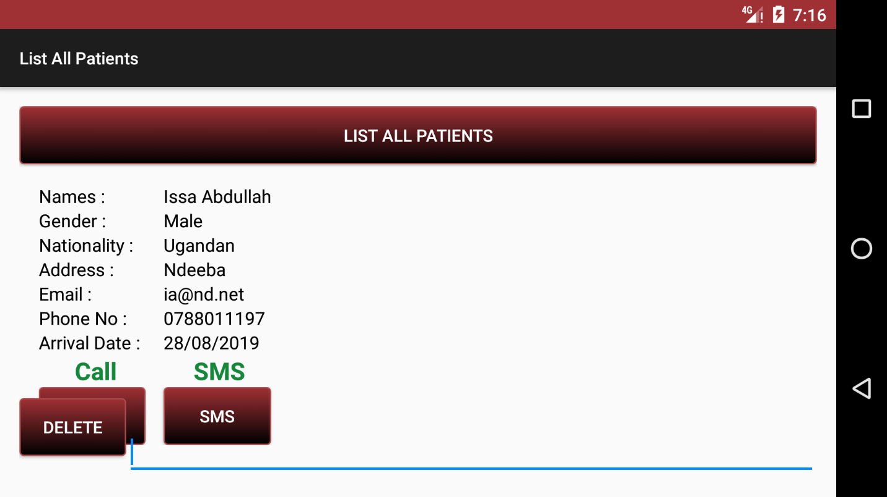

**Figure 16. ADD PATIENT**

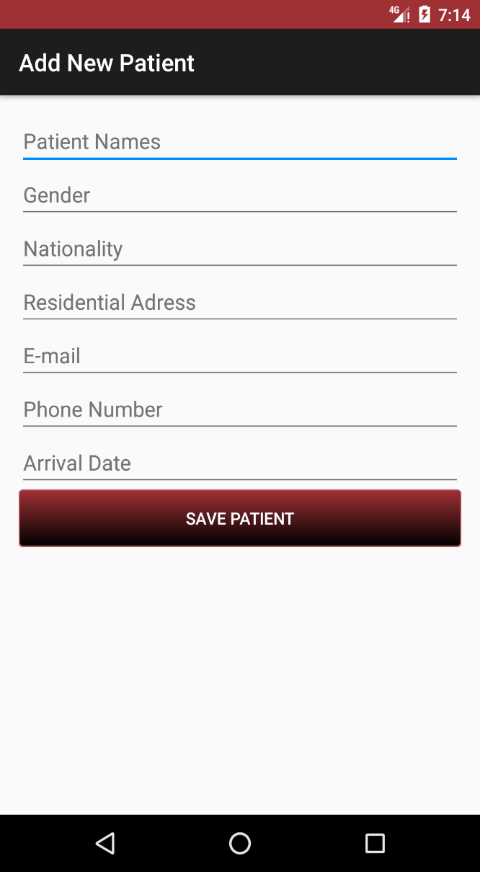

### APPOINTMENT MODULE

**Figure 17. APPOINTMENTS LIST INTERFACE**

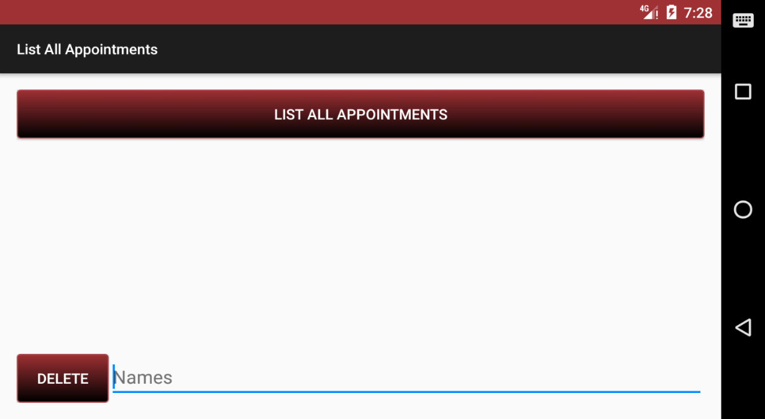

**Figure 18. ADD APPOINTMENT**

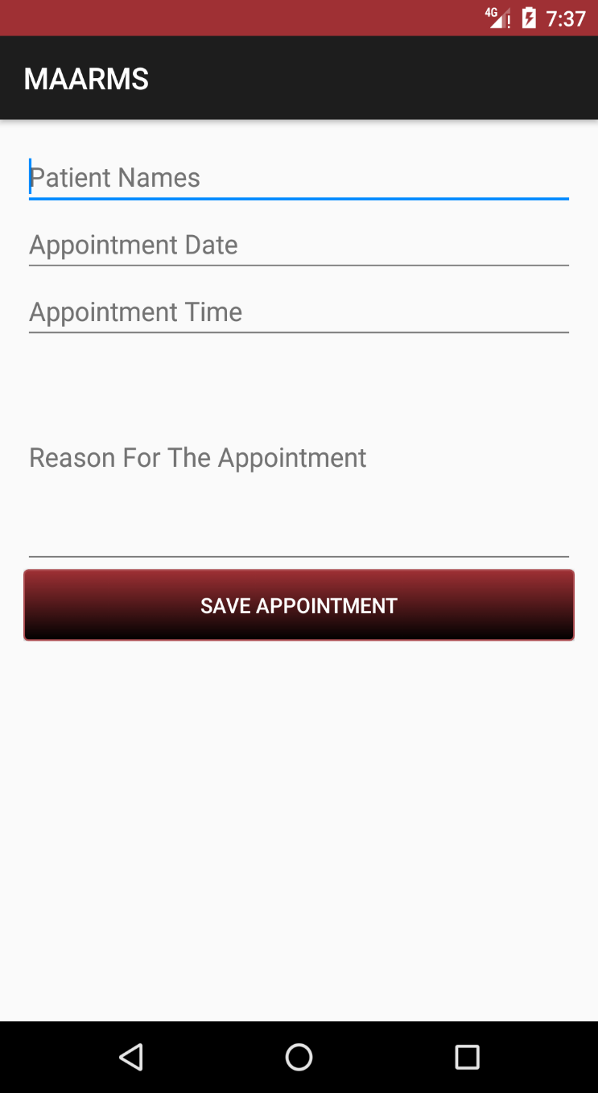

## DISCUSSION

From the above facts we can devise the way the participants in the new system should be in the figure below;

The major changes from the prototype are:

* A doctor can now digitize everything from patients, appointments, tests, medication, visits
* Everything is now electronically based, thus hopefully easier to access and backups can be made through reports
* Modify the searching to be by name rather than by sensor data

These changes were justified by analyzing the user feedback given to us in the preceding iteration.

**CONCLUSION AND RECOMMENDATION**

The system was successfully created; it could save patients data, appointments scheduling, medical tests, prescription info, visitation data and the generation of reports. In addition, it was time saving, providing backup, archiving data and provided schedule reminder for patients. Reports were also easy to retrieve and it provided electronic documentation as well as easy appointment making. There was also a reduction in mother to child transmission.

The system is good and useful; however, it saves all its data on local storage. This is bad since the local storage can have a problem, hence loss of all application data. For future work, the system can be improved to store data on the cloud.

The recommendations are mainly for the school; the university should provide enough learning material. They provide little information that cannot be used at least as a reference to develop advance, usable, real world application.

We recommend that the system be used by other health facilities with in Uganda because we believe that the system can effectively and efficiently display antenatal patient information, send SMS notification and health tips, make phone calls and provide appointment reminders.

We would like future research to focus on developing the mobile application for windows phone users and iPhone users.

**REFERENCES**

Brendon W (1989) Records management encyclopedia of library and information

Science. New York. Marcol Dekker.

Chibita D (2002) how do lost files vanish, New vision 18th 2002

Dosset P (1992) Handbook of special librarianship and information, London Unwin brothers Ltd.

Kallaus (1992) Records management, United States of America, south western publishing company.

Kent (1998) Specialized information Centre, Vikus publishing.

Penn J (1994) Record management Handbook. Gover publishing limited.

Wallace P (1987) Records management integrated information. Canada

Wasike A. (2001) Chopper file goes missing, New vision 20th 2001.

A vision D.E and Fitzgerald (1995) Information systems development methodologies.

Beynon-Davies P. (2002) An introduction to informatics in organization.

Boudrean, MC, Geffen D, Straub Dew (2001) Validation in information systems.

Carry N Prague and Michael R. Irwin (2002) Access 2002 Bible, by Henry minds Inc.

CS French (2004) Data processing and information technology 8th Edition published by O’Reilly.

CJ Date (2000) An introduction to database systems, 4th Edition, published by personal education Asia.

Dr EF Cod (180) Relation model of data for large shared databanks, published by IBM.

Eric A Smith, Etel Valor Whistler and Hank Marquis (2005) Visual Basic 6 Programming Bible, published by Whitley dreamtec India (p) Ltd.