**COURT CASE MANAGEMENT SYSTEM**

**Mr. Lubega John Bosco 1* OKAI CALVIN 1**

**St. Lawrence University, Uganda [Email. agendalubega@gmail.com]**

# ABSTRACT

# The study sought to appraise the court case management system, a case study of the chief magistrate’s court, lira district. The research was conducted using questionnaires and interviews, to improve data storing and retrieving for faster execution of ruling by the magistrate as data will be stored electronically retrieving data will be faster, efficient and reliable, to easy data backup process which will help in eliminating stagnating cases in court due to missing files when data is electronically stored making duplicate of the same data is easy than in the latter system, to maintain data integrity. This mean since data will not be exposed to everybody the data will be up to date and people with malicious intentions will not get access to the data and to eliminate court malpractices like corruption and intimidation by the people who get access to private data. A systematic random sampling was used for the data collection.

### The findings according to this paper found two divergent views, thus User requirements. These are basically statements in natural language of what services are expected to be provided and the constraints under which it must operate. The system allows a user to search for a given file or staff. This can be achieved using any of the file attributes displayed to the user. The system displays court case information for a selected case or staff. Non-functional requirements, performance Requirements - In order for the system to work efficiently, the device needs to be connected to the internet. This is to enable the user to access the updated version of the details in the server.

Security Requirements-The passwords of the users are securely stored in an encrypted format. The system automatically logs the user out in the case that there is a period of inactivity. The clients’ information needs to be confidential to all the staff.

Conclusive, throughout the development of this project I have been able to learn new concepts as well as strengthen my skills in other tools such as HTML, AJAX, JavaScript, Bootstrap, php and MYSQL. After testing the software, the following functions were proved to be working as expected.

**KEYWORDS: MYSQL, AJAX, BOOTSTRAP, PHP**

# INTRODUCTION

# The Judiciary is repositioning itself within the context of the Constitution of The Republic of Uganda1995. The Judiciary is involved in a major transformation programme with the competitive recruitment of the Chief Justice, other judicial offices as well as admin and paralegal staff. A major re-organization of the institution is currently underway to enable it fulfill its constitutional mandate under article 159 and meet public expectation. The following are the courts we have in Uganda.

# THE SUPREME COURT

The Supreme Court is the highest Court in Uganda, and is the final court of Appeal. The

Supreme Court only decides cases on appeal from lower courts save for presidential election petitions, where the Supreme Court has original jurisdiction, which means that any aggrieved candidate in a presidential election has to petition the Supreme Court directly. The decisions of the Supreme Court form precedents, which all lower courts are required to follow.

The Supreme Court bench is constituted by the Chief Justice and not less than six Justices.

However, when sitting as a constitutional court, the Supreme Court shall consist of a full bench of seven justices has to be present. The president can for that purpose appoint an acting Justice in the event that any of the justices are unable to attend. The decisions of the Supreme Court form precedents that all lower courts are required to follow.

**COURT OF APPEAL / CONSTITUTIONAL COURT**

The Court Appeal was established by the 1995 Constitution. It is an intermediary between the Supreme Court and the High Court and has appellate jurisdiction over the High Court. It is not a Court of first instance and has no original jurisdiction, except when it sits as a Constitutional Court to hear constitutional cases.

The Court of Appeal consists of: The Deputy Chief Justice and such number of Justices of Appeal not being less than seven as Parliament may by law prescribe. The Court of Appeal shall be duly constituted if it consists of an uneven number not being less than three members of the Court.

Cases coming before the Court of Appeal may be decided by a single Justice. Any person dissatisfied with the decision of a single Justice of Appeal is, however, entitled to have the matter determined by a bench of three Justices of Appeal, which may confirm, vary or reverse the decision. Cases decided by the Court of Appeal can be appealed to the Supreme Court, but the Court of Appeal is the final court in election petitions filed after Parliamentary elections or elections provided for by the Local Government Act.

**THE HIGH COURT**

The High Court of Uganda is the third court of record in order of hierarchy and has unlimited original jurisdiction, which means that it can try any matter as conferred on it by the Constitution and other law. Appeals from all Magistrates Courts go to the High Court.

The High Court consists of the Principal Judge and twenty-five judges or such higher number as prescribed by Parliament by resolution. The High Court is headed by the Principal Judge who is responsible for the administration of the court and has supervisory powers over Magistrate's courts.

The High Court has seven Divisions: The Civil Division, the Commercial Division, and the Family Division, the Land Division and the Criminal Division, the anti-corruption Division and the war crimes division

# SUBORDINATE COURTS

Subordinate Courts include the Chief Magistrates Court, Industrial Court Magistrates Grade I and II Local Council Courts levels 3-1 (sub county, parish, and village).

# Statement of the Problem

# In Uganda roughly 70% of courts don’t use electronic filing which is prone to a lot of problems like case file misplacement, case files going missing and this leads to injustice in the country

# About 50% of the cases which have never been solved is due to poor storage of files or even misplaced and this has led to injustice and high rate of malpractices.

# The current system do not guarantee for privacy and confidentiality of the crucial data which exposes crucial data to this will complimize the data integrity the new system will safe guard the data integrity by imposing secret keys to access data stored the database of the system.

# There is a lot of malpractices in most court since the current system do not keep track of every transactions carried out in court and this allows malpractices to occur ,the new system will keep track of all transactions and since there is measures of keeping this data safe by use of secret password.

# Objectives, research questions and hypothesis

To explore the implementation of electronic court records management in Ugandan Courts.

To improve data storing and retrieving for faster execution of ruling by the magistrate as data will be stored electronically retrieving data will be faster, efficient and reliable.

To easy data backup process which will help in eliminating stagnating cases in court due to missing files when data is electronically stored making duplicate of the same data is easy than in the latter system.

To maintain data integrity. This mean since data will not be exposed to everybody the data will be up to date and people with malicious intentions will not get access to the data.

To eliminate court malpractices like corruption and intimidation by the people who get access to private data.

The main research question of this project is how best the researcher can develop Court Case Management System.

1. What design should a Court Case Management System look like?
2. What features will familiarize users with the Court Case Management System?
3. Who will access the Court Case Management system?
4. How will the new Court Case Management system be accessed?

# Significance of the knowledge

In Uganda, the public sector is facing pressing challenges to provide efficient service delivery. In recent years, a number of legal and judicial issues and crises in Uganda have been brought to the attention of the public, especially by the main stream newspapers. The issues are, among others, the long delay of cases, the attitude of lawyers, the shortage of judges, the absence of written judgment by judges, which sometimes deny the right of appeal to the accused, or generally deny certain rights of the public at large. Moreover, the increased demands of the public need to be catered for.

Any shortcomings resulting from the poor management in public service delivery may lead to the question of integrity of the public sector as well as the issue of survival, respect and vigor of Uganda as a nation.

This study is expected to offer favorable contributions to the body of knowledge for academicians and practitioners. In its theoretical contribution, the study is expected to identify critical dimensions or factors in electronic court records management. Practically, the research is

Projected for the enhancement of overall quality of judiciary administration by increasing integrity, efficiency and effectiveness. For court’s policy makers, this research can promote an improvement in the judicial corporate administration as well as building an excellent service and reputation of the judiciary.

**Scope**

The system will be specifically designed to publish relevant content and information regarding court case, and allow access to various cases that are on-going or have been handled by a particular court of law. This will be accessed by registered personnel visiting a particular court premise of the chief magistrate’s court that is found in Lira district for three months

# LITERATURE REVIEW

The efficiency of service delivery sets the benchmark for public service excellence.

Effective records management system guarantees the accountability and integrity of an organization that provides services to the public at large and serves as strategic resource for government administration (Hassan 2007).

A reliable and accurate case file system is fundamental to the effectiveness of day-to-day court operations and fairness of judicial decisions. The maintenance of case records directly affects the timeliness and integrity of case processing. There is a pressing need for a clear definition of legal framework (Johare2007).

Experience by countries in international Records Management Trust (IRMT) research (ITRM 2004) proved that for a system to work with authority, trustworthy and reliability, it needs a strong legal framework of its own.

Organizations today not only have to comply with regulations, but also have to maintain a balance between operational record keeping requirements, minimizing liability of storing private information and customer privacy preferences (Ataullah 2008). International Records Management Trust (IRMT, 2004)reveals several key issues identified by legal and judicial record case studies:

* the need to raise the status and priority of recordkeeping;
* the need to allocate greater resources to supporting recordkeeping infrastructure, for example, storage facilities and equipment (for paper and electronic records);
* the need to develop records management policies and standards, for example, in relation to access to and long-term preservation of paper and electronic records;
* the recognition that computerized case management systems have the capacity to improve case flow management and access to information, but the danger of regarding computerization as a means of solving all management, resource and information problems;
* the need for an information strategy and business case, based on the requirements of all key stakeholders, before embarking on the computerization of case administration;
* the value of pilot computerization projects to build confidence and capacity and
* the importance of standardized formats and templates for common documents.

The biggest challenge when organizations set to move forward by embracing IT in its administration is to retrain the people. For a court registry, the lack of experts who know both registry office and information management standards become the first hurdle in implementing change. IRMT(2004) pointed out a number of issues identified by legal and judicial record case studies with respect to people aspect:

* the need for consistent and authoritative instructions on the preservation or destruction of court case records (both paper and electronic);
* the importance of having a high level ‘champion’ within the courts to promote good practice in records and information management ;
* the need for professionally trained records managers within judiciaries;
* the need for formal training and training materials in judicial records and information management and
* The importance of having expert advice and guidance available to those with responsibility for records and information management in the courts.

# RESEARCH METHOD

The project will apply a prototype method, the basic idea here is that instead of freezing the requirements before a design or coding can proceed, a throw away prototype will be built to understand the requirements. This prototype will be developed based on the currently known requirements.

By using this prototype, the user will get an “actual feel” of the system, since the interactions with prototype can enable the client to better understand the requirements of the desired system.  Prototyping is an attractive idea for complicated and large systems for which there is no manual process or existing system to help determining the requirements. The prototype is usually not complete systems and many of the details are not built in the prototype. The goal is to provide a system with overall functionality.

# Data Modeling

As a means of understanding the user requirements from the gathered information, structural modeling tools such as Data Flow Diagrams, Data Dictionaries and Entity Relation Diagrams will be used. These tools also guide in establishing the relationships amongst entities.

Data Dictionaries are a set of data about data that contains definitions and representations of data elements. These were used to determine rigorously each and every data element, data structure and data transform. This enabled the researcher provide documentation, eliminate redundancy and validate data flow diagrams. The dictionaries also provide consistence between data items across different tables and ease data analysis.

Data Flow Diagrams are graphical representations of the flow of data through an organization. DFDs will be used to show the relationship between processes and data, determine requirements of the users and provide special description of requirements and system design.

Nevertheless, using data flow diagrams alone will emphasize and show how the system’s primary data entities are related.

In order to emphasize and show this relationship, ERDs were used. An ERD is a data modeling technique that creates a graphical representation of the entities, and the relationship between entries.

# Population and Sampling Design

Population can be defined as the entire group of elements regarding which researchers look for inference about (Cooper & Schindler, 2006). Target population refers to the whole group of persons who comprise of common observable uniqueness (Mugenda, 2008). The more precise a population of concern is clear, the healthier the capability to explain and describe the behaviour proposed to be deliberated. The target population which will contribute to the collection of primary data is 30 staff members of the Chief Magistrate’s court of Lira district.

The target population was as follows:

# Table 1. Showing Target population

|  |  |
| --- | --- |
| **Category** | **Population (Frequency)** |
| Bench clerks | 5 |
| Informants | 10 |
| Magistrates | 2 |
| Prosecutors | 10 |
| Registrars | 3 |
| **Total** | **30** |

# 

# Data Collection Methods

This study collected Primary data for analysis. The selection of a instrument and tool depends mostly on the attributes of the research topic, subjects, problem question, design expected and objectives, expected data and results (Kothari, 2004). Cooper & Schindler (2006) explain that primary data is information gathered straight from the respondents and for this research questionnaires were used. The questionnaire designed for this study aimed at capturing demographic information and data based on the research objectives, infrastructure challenges, legal and security challenges and customers’ exposure and literacy to computers and information technology challenges.

The researcher will use both primary and secondary sources of data.

# Primary Data

The data will be obtained from the staff of the chief Magistrates court in Lira district. The information will be obtained by use of interviews, observation and review of documents.

# Secondary Data

This data will be obtained from management, booking Forms, published materials, which included journals, textbooks magazines, internal reports and newspapers.

# Data Collection:

Data collection is the systematic gathering of data for a particular purpose from various sources. In this section, the researcher explains several methods that will be used in collecting data that include interviews, observation, and review of existing documents.

# Interviews

An interview is a formal or informal meeting between two or more people with an intention of obtaining information about something in particular, Lynn (2005). One of the data gathering tools that will be used in the interview research method is an interview guide; a set of guiding questions. The interview guide that will be used in this project will consist of semi-structured questions. During the interviews, the researcher will have the opportunity to ask additional questions to obtain clarification depending on the interviewee’s response to the specific set of questions in the guide. The open-ended questions will allow the interviewee to respond in any way that seemed appropriate.

Interviewing as a technique for information gathering is chosen because of the following reasons:

# Observation

Observation is watching something attentively and taking note of anything it does. It is therefore a Law with five component parts: Logic, Reason, Discretion, Discrimination and Discernment, that equal Understanding. The researcher will watch as a person at the organization performs activities in order to learn about the manual or current system.

The researcher will use this technique because of several factors and they include:

* The researcher will be able to study the existing system in its natural setting, thereby providing a richer understanding of the subject.
* Observation also helps the researcher reveal certain problems on their own.
* Provide highly detailed information from an external perspective on what actually occurs in website.
* It is used to record actual system behavior and the actual recorded behaviors were compared to interviewees’ statements to check for the validity of their responses.
* Provide less biased descriptions than other methods.

# Data interpretation and Analysis

Data analysis is the process of cleaning, transforming, analyzing, and modeling data gathered in a research. Data analysis models that will be used in the research include both quantitative and qualitative techniques (Yates, Moore, & Daren, 2008). Data was coded according to different variables of the study for ease of data entry and interpretation. Descriptive Statistics and SPSS will be used to help the researcher to illustrate the data and establish the amount used. The findings shall then be presented using charts and tables. Quantitative data collected will be analyzed by the use of descriptive statistics using. Strategic package for social sciences (SPSS) and presented through percentages, means, standard deviations, frequencies and Kаrl Person’s coefficient of correlation. The findings were presented using frequency distribution tables and figures. From the data that will be collected the user requirements specifications to suit the needs of the court system will then be identified.

# Hardware requirements

These refer to the minimum hardware requirements of a hardware resource entailed by the system.

To ensure faster processing of data i.e. Security information of an area searched for by the user, a system (server) with processor of at least 1GHZ speed, 512MB RAM and storage space of at least 20GB to handle all the users requests.

The table below shows the summary of hardware requirements.

# Table 2. Showing summary of hardware requirements.

|  |  |  |
| --- | --- | --- |
| Hardware | Minimum requirement | Reason |
| CPU speed | 1.8GHZ | Moderate |
| RAM | 512MB | Moderate |
| Disk space | 50GB | Enough |
| Bandwidth | 100Mbps | Enough |

# 

# Software requirements

The system required supporting software. The software ranges from operating system to some utility software .Windows operating such as Windows 7 and Windows 10

MySQLServer was required to interpret SQL queries/commands that were used in the implementation of the database and data retrieval from the database.

WampServer was used on windows operating system to process all requests and display results on web pages.

A number of web browsers can be used for this system which include; Mozilla fire fox, Netscape Navigator, Internet Explorer and Google chrome.

**Table 3. Showing summary of software requirements.**

|  |  |  |
| --- | --- | --- |
| Software | Minimum Requirement | Reason |
| Web server | WampServer | Extensible Web server |
| DBMS | MySQL Server | Easy to use and scalable |
| OS | Windows 10, windows 7 | Proprietary Support |
| Browsers | Mozilla, Google Chrome | Can run all web applications |

**Figure 1. below showing a flow chart that demonstrates how the system works.**



Figure 1: shows an architectural design of the system

# Architectural design of the system



Figure 2: shows an architectural design of the system

# context diagram of the system



Figure 3: The context diagram of the system

Entity Relationship Diagram

**Figure 4. shows an ERD** representing the main entities in the system and the different relationships between these entities. Entity Relationship diagram representing the online poultry management information system.



Figure 4. Entity relationship diagram of the system

Research RESULTS

# System implementation results

Web interfaces were designed where users view crime information on maps; administrators manage every aspect of the project.

The figures below show the following interfaces;

# Figure showing the home page of the system.

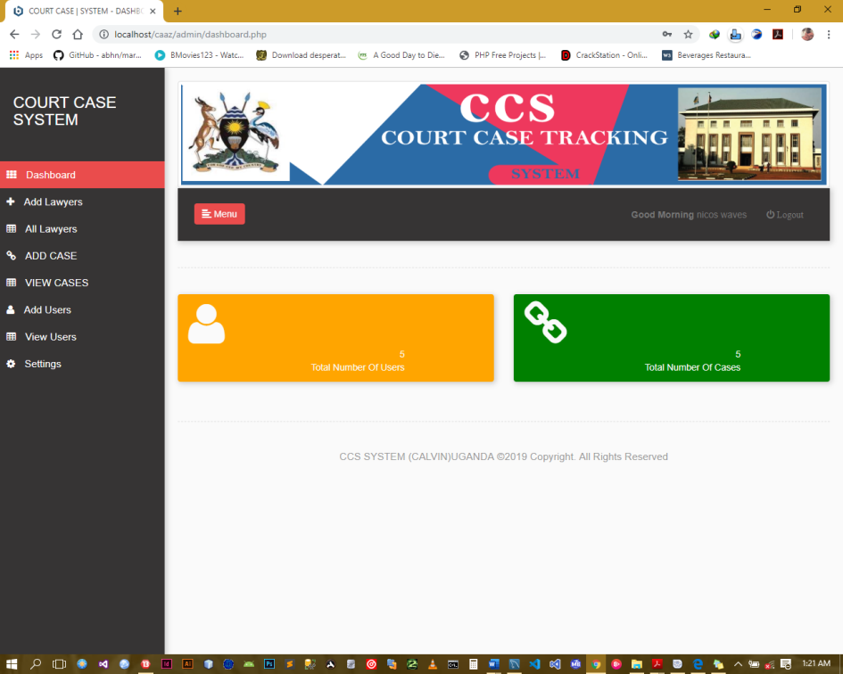

Figure 6: Home page of the system

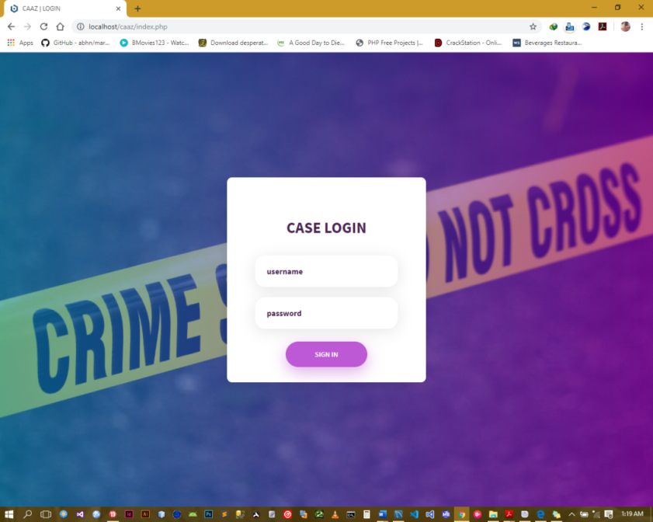

Figure 7: The login page of the system

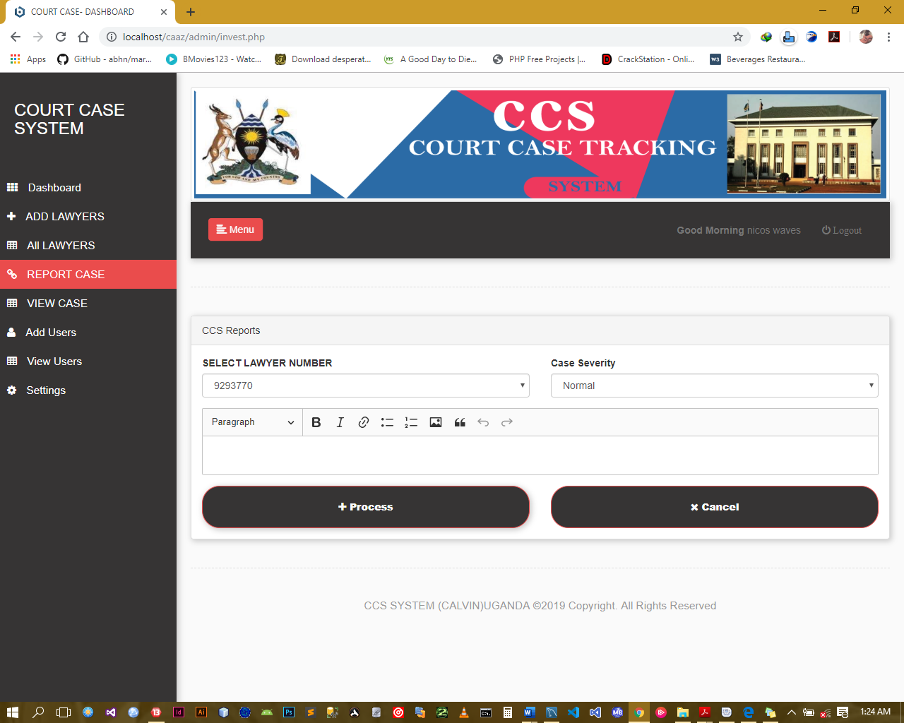

Figure 8: Court case information reporting page on the system.

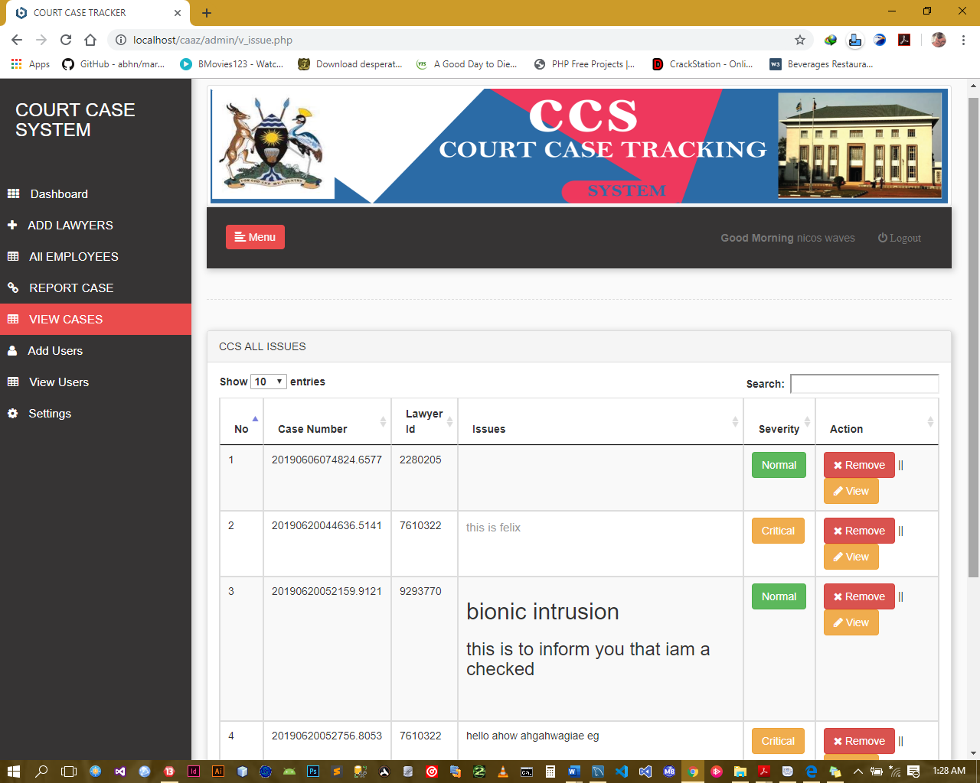 Figure 9: Court cases incident listing page.

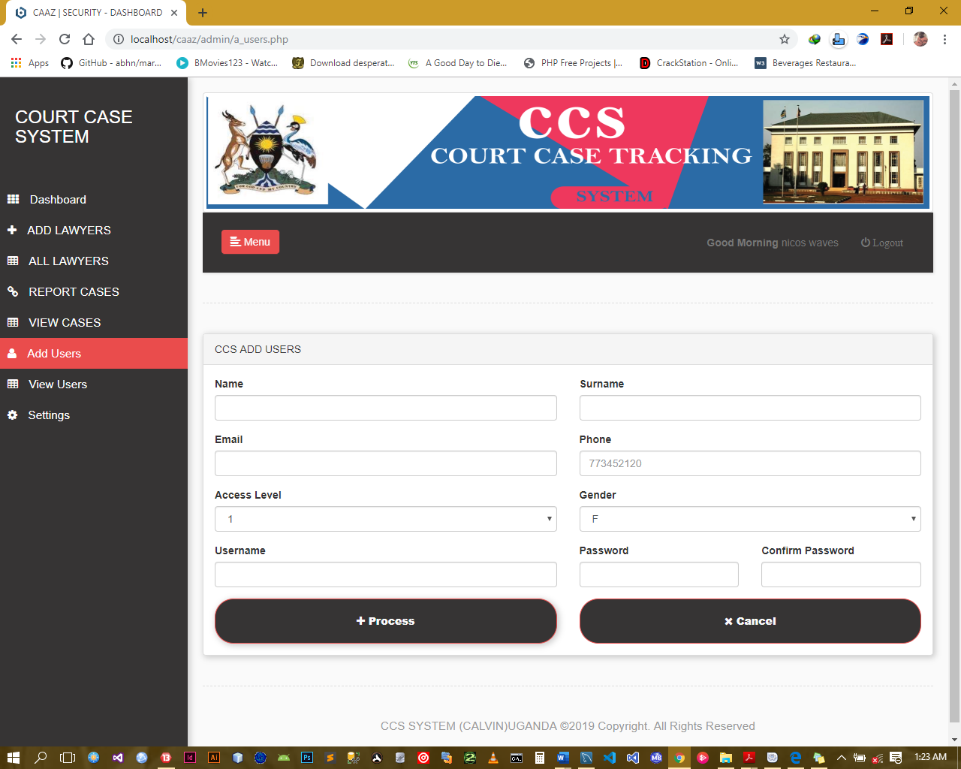

Figure 10: Interface for adding user.

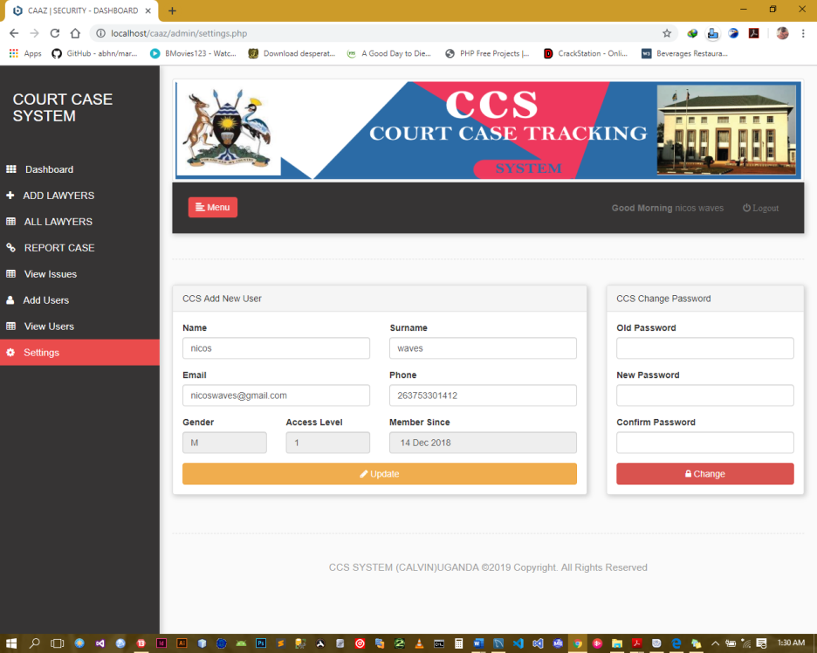

Figure 11: Settings page.

# 

# Discussion

Throughout the development of this project I have been able to learn new concepts as well as strengthen my skills in other tools such as HTML, AJAX, JavaScript, Bootstrap, php and MYSQL.

After testing the software, the following functions were proved to be working as expected.

* New clients can be registered into the software
* The clients can be viewed in a well formatted table
* The admin can add a new staff into the database
* The admin can view a table containing the details of the other staff
* The users can add/open a new file/case
* The user can sort/search for a given file from the database using any of the parameters
* The user can view the details of the a given case
* The user can upload/add a reference material which is accessible to all the user of the system
* The user can refer to the reference materials at any point on time
* Reports on clients and/or files can be generated instantly

The legal management software will go a long way in helping the law firms to effectively manage their documents.

# Conclusion and recommendation

Malicious hackers or technical glitches can open up lawyer’s cloud storage to breaches that could lead to violation of the obligation of confidentiality. So the users should not rely on the cloud storage as the only primary location of the clients’ files. This can be addressed by saving a copy of the files in the cloud in the local storage. The files could also be encrypted before uploading them to the cloud (Ezor, 2014).

# Recommendations

Due to the constraint in time I highly recommend that in the next versions of the Court Case Management software the following features be implemented.

* More security features should be implemented so that the information is secure.
* The software should be linked to a calenderer engine for synchronization and easy planning.
* The email engine should also be incorporated so that the clients can be directly contacted on the progress of their cases.
* A module should be added such that after collection of large amounts of data, the system can apply data mining techniques to predict the probability of winning the case.

**REFERENCES**

# doi:www.ncsc.org/~/media/Files/PDF/Education%20and%20Careers/CEDP%20Papers/2006/LalondeRobertCEDPFinal0506.ashx Doi:www.ubrisa.ub.bw/handle/10311/1164

# Doi:www.thompsonreuters.com/products/legal/c-track-court-case-mgmt/cooperative-court-case-management-system-development-ann-lavery.pdf

Duranti, L. (2009). 'From Digital Diplomatics to Digital Records Forensics,' Archivaria 68:39-66.

Goh, E. (2005). 'InterPARES 2 Project-Case Study 21 Final Report: The Electronic Filing System (EFS) of the Supreme Court of Singapore,' Retrived October 5, 2010 from

http:// interpares.org.rws/display_file.cfm?doc=ip2_cs21_ final_report.pdf

Hamid, S. A. (2010). 'Personal Communication,' October 11, 2010.

Isa, A. M. (2009). PengurusanTerasKecekapan Dan KetelusanOrganisasiTinta: PengadaptasianTeknologiDalamPenyebaran Maklumat. Bil 18. 40-49.

Motsaathebe, L. &Mnjama, N. (2009). "The Management of High Court Records in Botswana," Records Management Journal, 19(3), 173 - 189.

Mnjama, N. &Wamukoya, J. (2007). "Egovernment and Records Management: An Assessment Tool for e-Records Readiness in Government," The Electronic Library, 25(3), 274 - 284.

National Center for Court Excellence (2009). 'Court Tools (brochure),' Retrived October 5, 2010 from http://www.ncsconline.org/D_Research/CourTools/tcmp_courttools.html

National Center for Court Excellence (2009)."International Consortium for Court 2010from

<http://www.courtexcellence.com/pdf/IFCEBrochure.pdf>. Excellence (brochure),Retrived October5,

National Center for Court Excellence (2009)."International Framework for CourtExcellence," Retrived October 5, 2010 from<http://www.courtexcellence.com/pdf/>IFCEFramework-v12.pdf.

National Center for Court Excellence (2009).'Measure 6: Reliability and Integrity of CaseFiles (brochure),'RetrivedOctober 5, 2010fromhttp://www.ncsconline.org/D_Research/CourtTools/Images/courtools_measure6.Pdf

Rahmah, (2008). 'Records ManagementReform in Malaysian Court of Appeal,'

Roper, M. (1999). 'Managing Legal Records:Managing Public Sector Records- A StudyProgramme,' London: International RecordsManagement Trust. Retrieved September 12,2010, fromhttp://www.irmt.org/educationTrainmaterials.html

Rosimah, (2010). 'Personal Communication,'October 10, 2010

Saman, W. S. & Haider, A. (2010), 'Towardsthe Court Records Management Reform,' InProceedings of the National Conference onShariah and Law, Kuala Lumpur, November2-3, 2010

Shariah Judiciary Department of Malaysia(2005). 'Synopsis of E-ShariahImplimentation History,' PercetakanNasional Malaysia Berhad, Kuala Lumpur.Sidek Hassan, (November 5, 2007).'OpeningSpeech,' Records Management Convention,Putrajaya

Smith, T. J. & Miller, R. D. (2007). ElectronicRecords Management: New Obligations, NewTools. Community Banker. RetrievedOctober 5, 2010 fromhttp:www.klgates.com/files/publicationd89fdaf9-751a-41fc-a1a2-5da5da3b24551cb/presentation/PublicationAttachment/51b3bed1-05b3-44416-8b59-61b1-

61b161a8d7bb/article_smith_miller_0607.pdf

Spratt, C. (2007). 'Electronic Access to CourtRecords,' News Media and the Law.ReportersCommitte for Freedom of thePress. Retrieved October 5,2010, from

http://www.highbeam.com/doc/1P3-13043971.html.

Sultan, H. (2010). 'Personal Communication,'October 1, 2010

Thurston, A. & Cain, P. (1995). TheManagement of Public Sector RecordsProject: Managing the Records Lifecycle.Information Development, 11(4), 198-205.View publication